Precision and Concision
- Backbone of the writing assessment
- Word choice
- Redundancy (Look at the delete option first.)
  - Simultaneously – At the same time
  - Frequently – Quite often
  - Annually – Once a year, each year

Stye and Tone

- Question will be recognized by all four answers saying the same thing.
  - Usually, one answer choice will be highly academic or formal language, also perhaps wordy.
  - Usually, more than one answer choice will be colloquial—informal and conversational.
  - One answer choice will fit the style and tone of the context of the passage.

Syntax
- Question will be recognized by two complete sentences underlined in the passage.
  - Try to find what element or word(s) the two sentences may have in common and attempt to avoid repeating those elements or words when combining the sentences.
  - When combining the sentences, do NOT change the meaning of the two individual sentences.
  - Avoid awkward phrasing in the new combination.
  - The newly formed sentence most likely will NOT be the result of placing a semicolon between the two separate sentences.
  - You may or may not be able to eliminate based on sentences being grammatically incorrect.

End of Sentence Punctuation
- “Does pointillism use dots—or was it lines?” the weary art student wondered aloud, before falling asleep.
- In his 1532 book of political theory, The Prince, Niccolò Machiavelli poses the question of whether it is better to be loved or feared.

Within Sentence Punctuation
- Semicolon
  - 99 percent of the time on the exam, a period and a semicolon are interchangeable.
    - In these cases, the semicolon separates two independent clauses.
    - The semicolon WILL NOT be adjacent to a FANBOYS. (for, and, nor, but, or, yet, so) (We love to eat ice cream after dinner; so we bought two large gallons.)
    - The semicolon WILL be adjacent to conjunctive adverbs when they separate two independent clauses:
      - However, consequently, therefore, thus, accordingly, nonetheless, nevertheless, furthermore
        - I studied abroad in Spain for several years; however, I would not consider myself fluent in Spanish.
  - A semicolon can be used to separate items in a series when the items contain internal commas (1%) I like apples, cherries, and melon.
    - The committee reviewed the Jones Report, which was written in 2006; the Jackson Study, which came from the regional office; and the Commissioner's Report, which prompted the initial controversy.
- Colon
  - A colon is used after a complete sentence to introduce a list of items.
    - You will need to bring many items: sleeping bags, trekking shoes, and warm clothing.
  - A colon is used in or between sentences if the second part clarifies, emphasizes or gives additional details about the first. In this case, a conjunction is not used to join the two parts. The second part is generally an explanation, rule, or an example of the first part.
    - Coconut is used in Indian cooking: It enhances the flavor of the dishes.
  - The colon is used to introduce or put extra emphasis on a single word or a phrase.
    - I know what I must do: practice.
    - Remember the most important rule: the customer is always right.
  - In informal writing, the dash can replace the colon in the examples above.
- Dash (the very last concept on Khan is called parenthetical or nonessential phrases covers dashes in depth.)
  - A dash is used to set off an internal list or a parenthetical or nonessential phrase.
    - Allison enjoyed studying for Art History--her favorite class--because she was able to learn about Picasso and Monet.
Sentence Boundaries
- You must understand the concept of INDEPENDENT vs. DEPENDENT CLAUSES.
- This is a highly tested concept, and to answer the questions correctly, you MUST understand the concept of comma splices.
  - 5 methods to correct comma splices I like Italian food, my brother prefers Chinese.
    - Use a period to separate the two independent clauses
      - I like Italian food. My brother prefers Chinese.
    - Use a semicolon to separate the two independent clauses
      - I like Italian food; my brother prefers Chinese.
    - Use a comma and a fanboys (for, and, not, but, or, yet, so) to separate the two independent clauses
      - I like Italian food, but my brother prefers Chinese.
    - Use a subordinating conjunction, which will make one of the independent clauses dependent.
      - I like Italian food though my brother prefers Chinese.
- 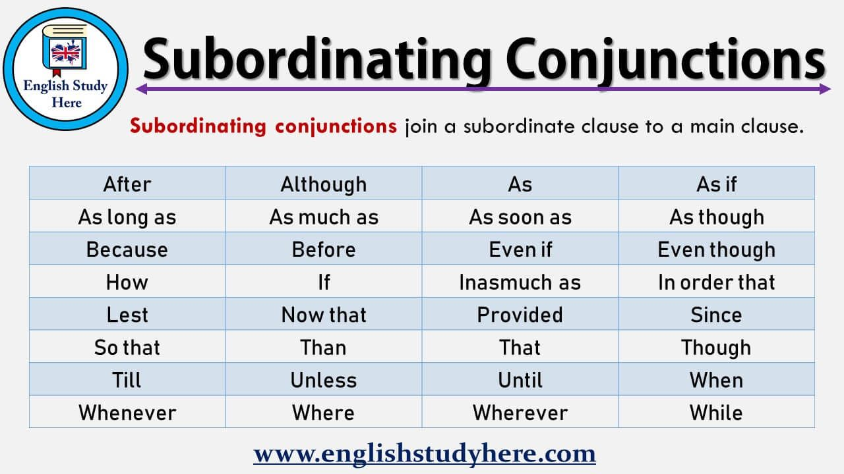

    - Separate the two independent clauses with a conjunctive adverb. Note that a semicolon comes before the conjunctive adverb and a comma follows it.
I like Italian food; however, my brother prefers Chinese.
- These conjunctive adverbs will be further discussed under the topic of subordination and coordination.

To answer sentence boundary questions and certain types of modifier questions correctly, you must be able to correctly identify relative pronouns.
- The main relative pronouns are who, that, which, where, when and whom. For the purposes of SAT, the most important two are which and that, specifically which. Which is often used to correct sentences on the SAT. Example:

In response to fears of a growing chocolate shortage, farmers are looking to a high yielding variety of the cocoa tree. Which was developed by Ecuadorian agronomist Hugo Castro.
- No change
- tree, which
- tree, and that tree
- tree; which

Make sure that the relative pronoun is as close as possible to the noun to which it is referring.

INCORRECT - The park at the end of our street, which is pristine, is a favorite place of mine.

CORRECT - The pristine park at the end of our street is a favorite place of mine.

Coordination and Subordination

- This type of question appears frequently and are easily identifiable.
- Rule #1 – Rule out any two answers that are remotely similar.
- Rule # 2 – Understand the relationship between the two sentences surrounding the transition.
- Rule # 3 – Try and study the chart and utilize it during your practice on Khan Academy to learn the various types.
- 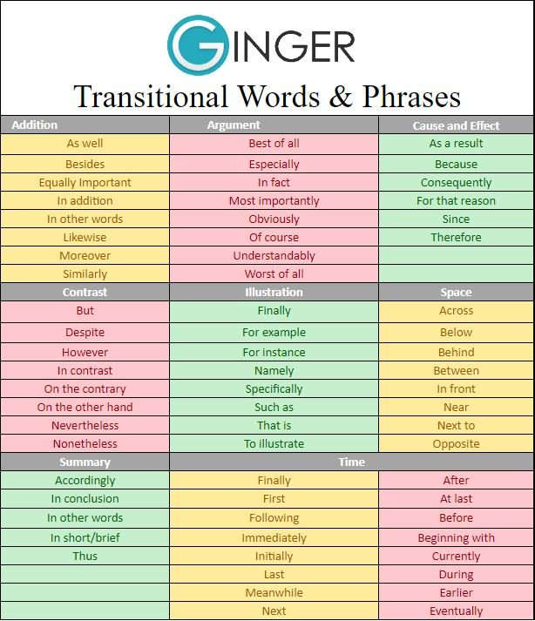

Parallel Structure
- These questions can sometimes be identified by noticing that the underlined portion of the question is part of a list. When dealing with a list, check for two concepts: parallel structure and items in a series (to be discussed later).
SIMPLE Example - Young children often find it easier to memorize lists of names by hearing, learning, and repeat simple, catchy tunes in which the list is made musical.
- No change
- repeating
- they repeat
- can repeat

Other types of parallel structure questions involve the following:
- not only….but also
- both….and
- neither…nor
- either…or

